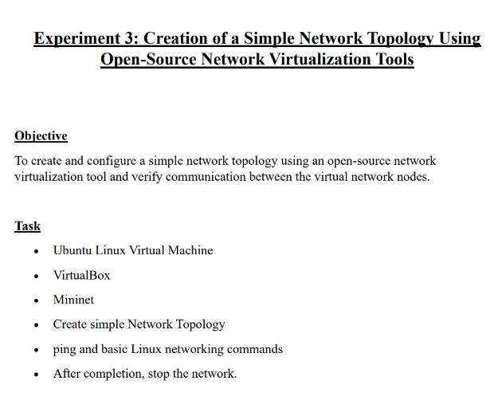
1. MININET INSTALLATION
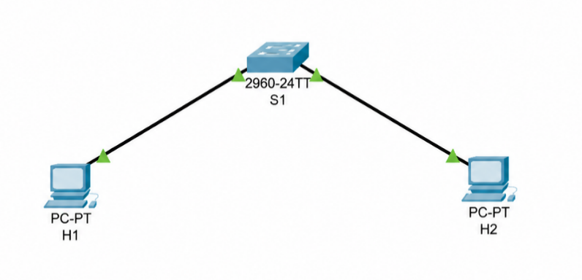
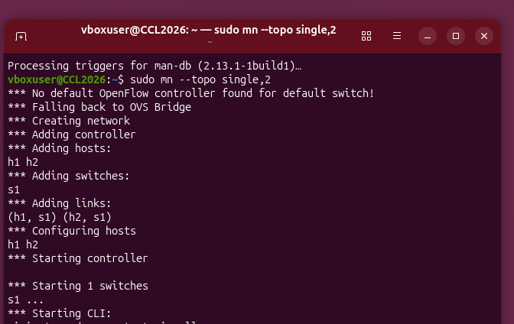
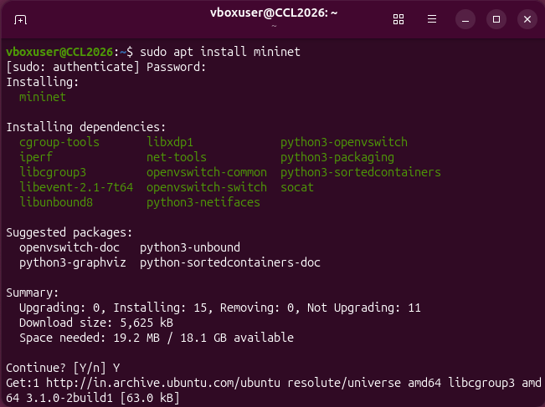
TOPOLOGY
1. STAR TOPOLOGY – a. STAR WITH 2 HOSTS

b. STAR WITH 4 HOSTS
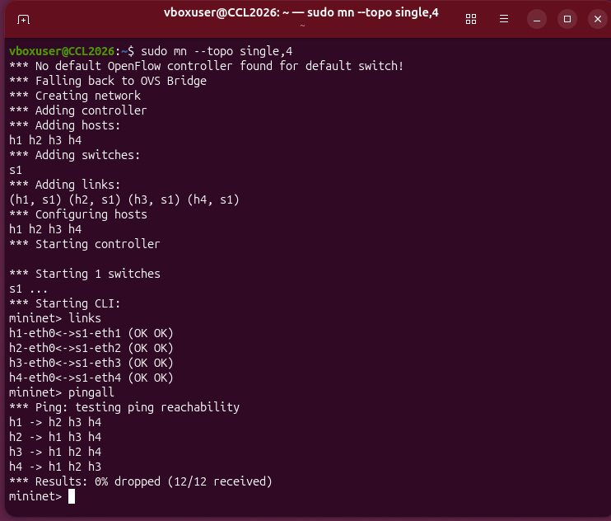
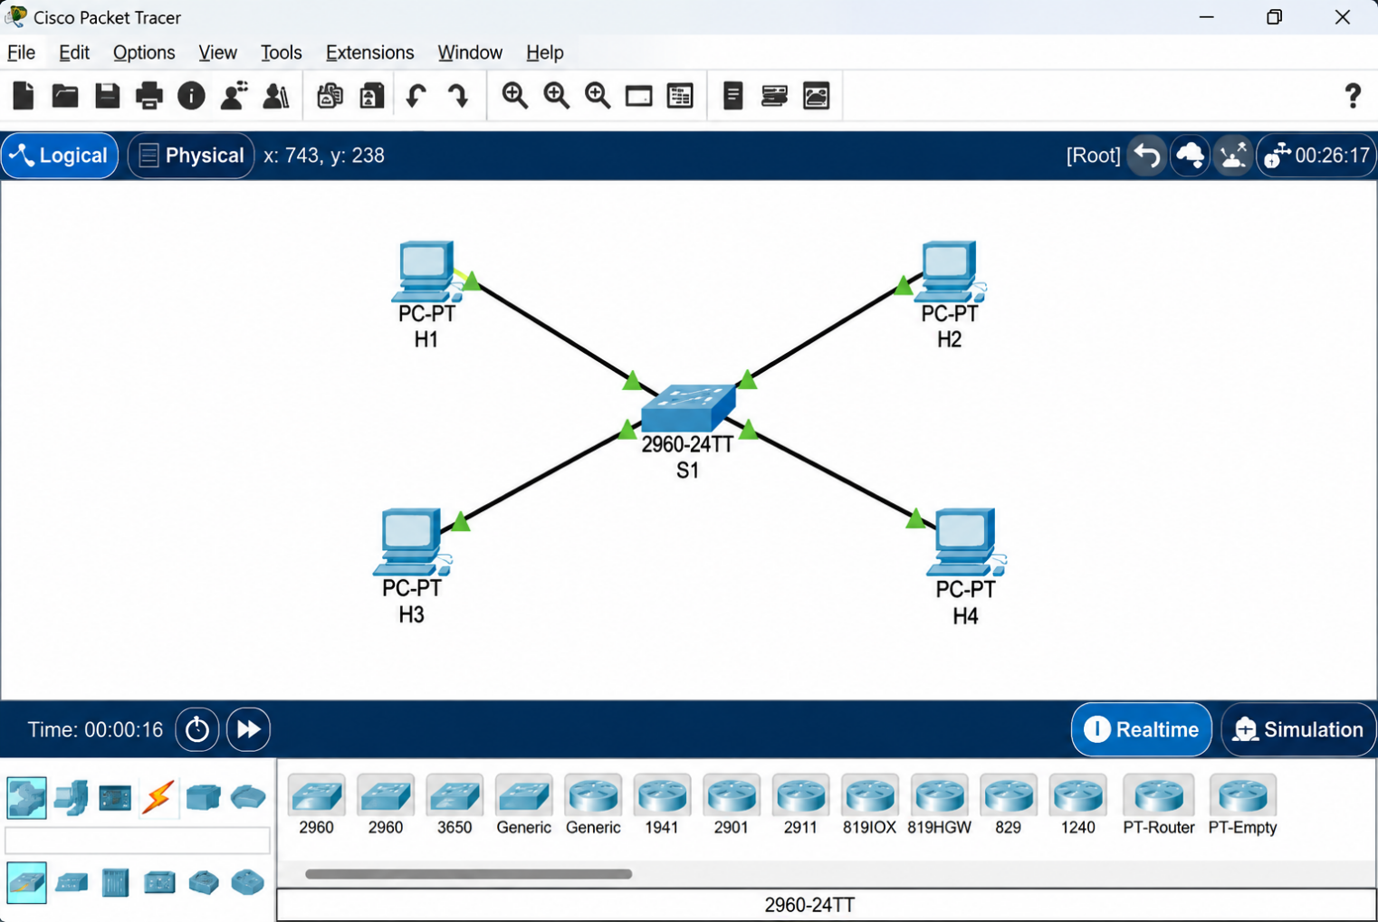

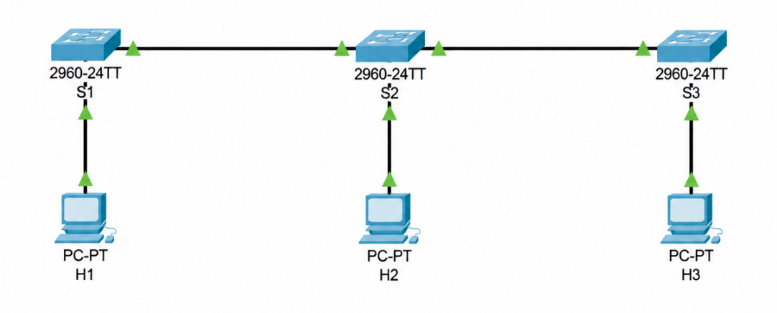
2. LINEAR TOPOLOGY – a. LINEAR WITH 3 HOSTS
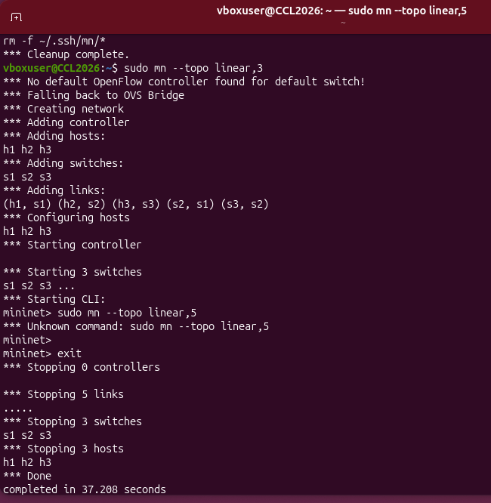
b. LINEAR WITH 5 HOSTS
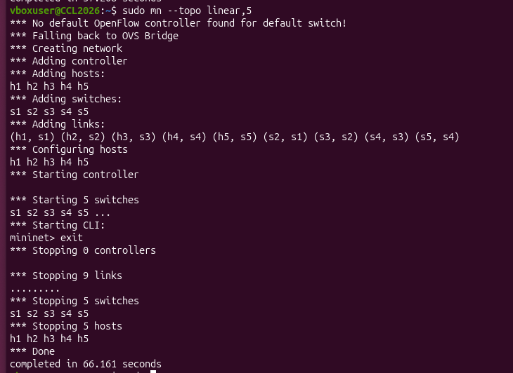
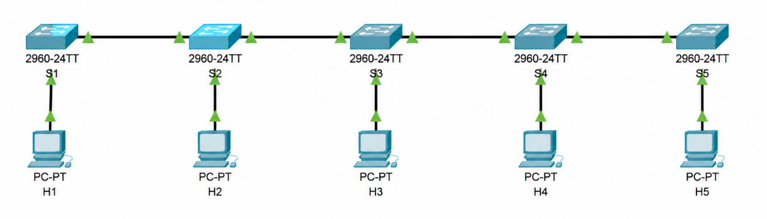
3. TREE TOPOLOGY
a. TREE WITH 4 HOSTS
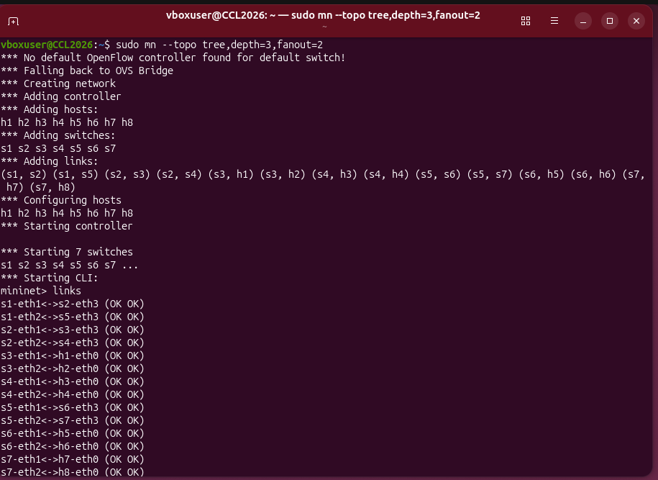
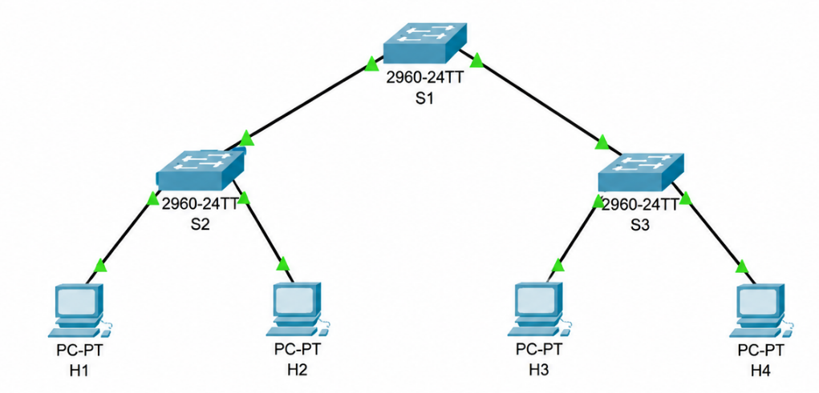
4. RING TOPOLOGY
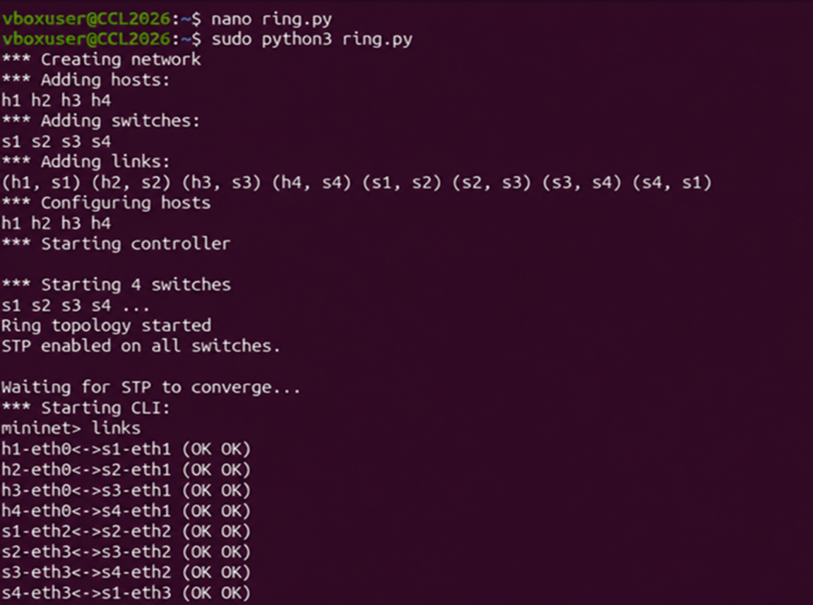
Ring Configuration and Links
Python Code
from mininet.topo import Topo
from mininet.net import Mininet
from mininet.node import OVSSwitch
from mininet.cli import CLI
from mininet.log import setLogLevel
import time

class RingTopo(Topo):

def build(self):
s1 = self.addSwitch('s1')
s2 = self.addSwitch('s2')
s3 = self.addSwitch('s3')
s4 = self.addSwitch('s4')

h1 = self.addHost('h1', ip='10.0.0.1/24')
h2 = self.addHost('h2', ip='10.0.0.2/24')
h3 = self.addHost('h3', ip='10.0.0.3/24')
h4 = self.addHost('h4', ip='10.0.0.4/24')

self.addLink(h1, s1)
self.addLink(h2, s2)
self.addLink(h3, s3)
self.addLink(h4, s4)

self.addLink(s1, s2)
self.addLink(s2, s3)
self.addLink(s3, s4)
self.addLink(s4, s1)

def run():

# Create topology
topo = RingTopo()

# Create Mininet network
net = Mininet(
topo=topo,
switch=OVSSwitch,
controller=None,
autoSetMacs=True
)

# Start network
net.start()

print("RING TOPOLOGY STARTED")

for s in net.switches:
s.cmd ('ovs-vsctl', 'set-fail-mode', s.name, 'standalone')
s.cmd('ovs-vsctl', 'set', 'Bridge', s.name, 'stp_enable=true')

print("STP enabled on all switches.")
print("\nWaiting for STP to converge...")
time.sleep(15)

CLI(net)
net.stop()

if __name__ == '__main__':
setLogLevel('info')
run()
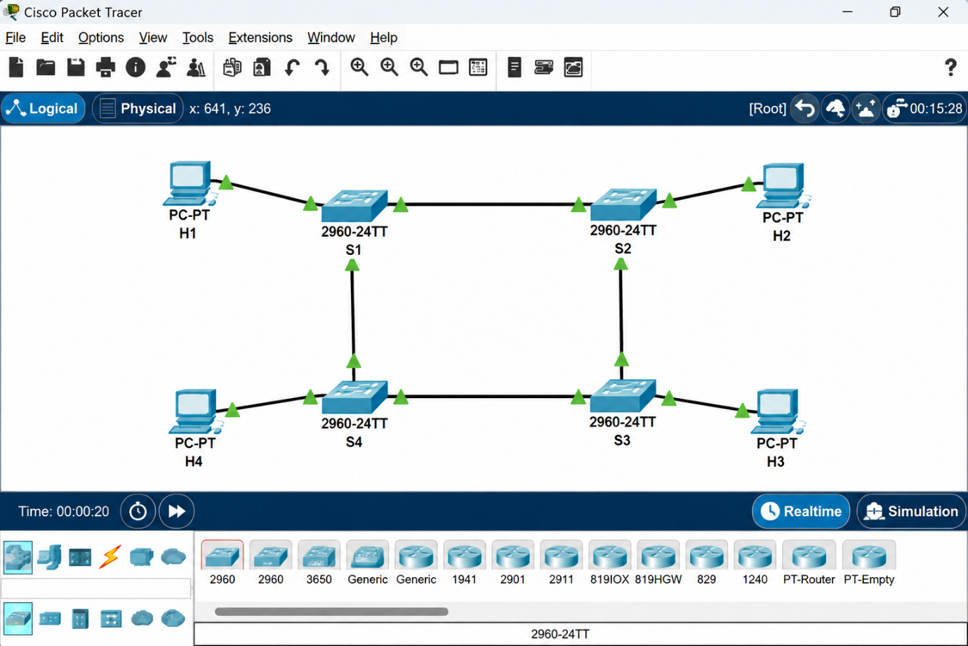
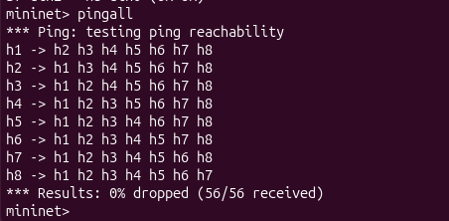
5. MESH TOPOLOGY
a. MESH WITH 4 NODES
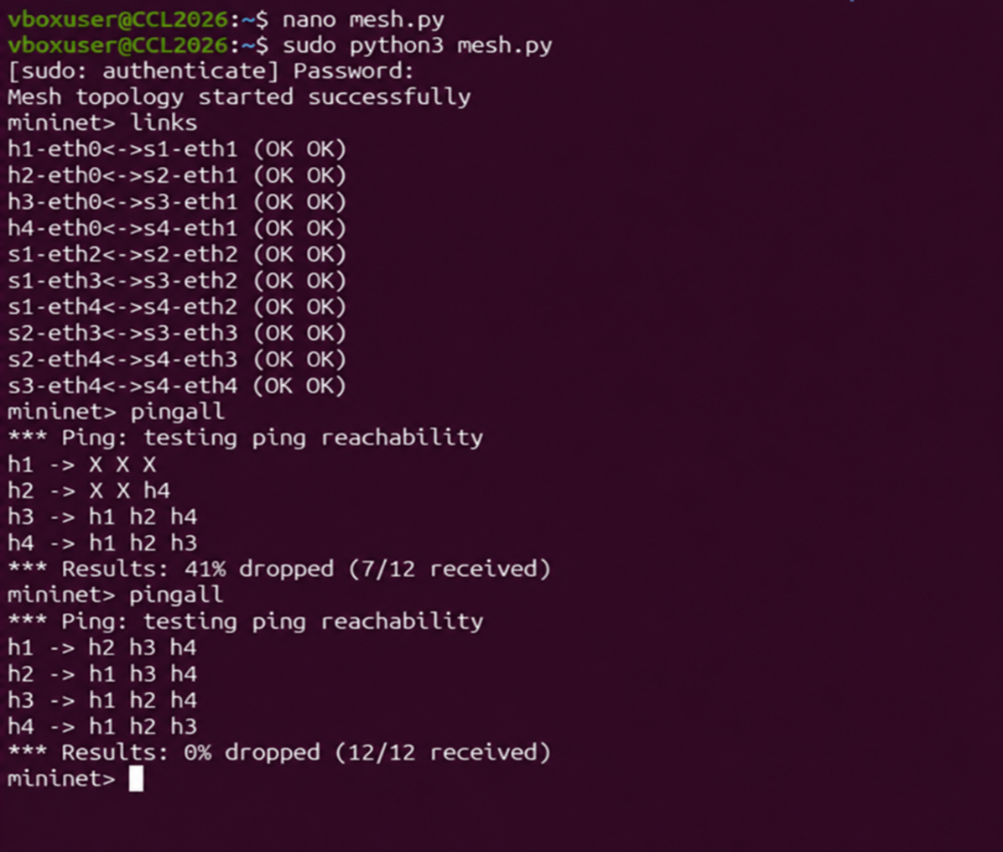
Mesh Config, links and pingall
Python Code
from mininet.topo import Topo
from mininet.net import Mininet
from mininet.node import OVSSwitch
from mininet.cli import CLI

class MeshTopo(Topo):
def build(self):
s1 = self.addSwitch('s1')
s2 = self.addSwitch('s2')
s3 = self.addSwitch('s3')
s4 = self.addSwitch('s4')

h1 = self.addHost('h1')
h2 = self.addHost('h2')
h3 = self.addHost('h3')
h4 = self.addHost('h4')

self.addLink(h1, s1)
self.addLink(h2, s2)
self.addLink(h3, s3)
self.addLink(h4, s4)

self.addLink(s1, s2)
self.addLink(s1, s3)
self.addLink(s1, s4)
self.addLink(s2, s3)
self.addLink(s2, s4)
self.addLink(s3, s4)

topo = MeshTopo()
net = Mininet(topo=topo, switch=OVSSwitch, controller=None)
net.start()

for s in net.switches:
s.cmd('ovs-vsctl set Bridge', s.name, 'stp_enable=true')
s.cmd('ovs-vsctl set-fail-mode', s.name, 'standalone')
print("Mesh topology started successfully.")

CLI(net)
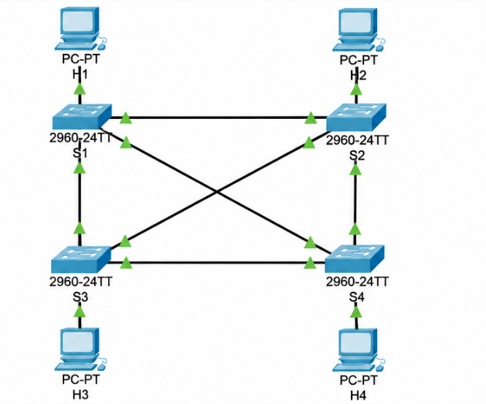
net.stop()

